

Topic test 2
Name: __________________________________

Chapter 3: Functions and sketching graphs

- Time allowed: 45 minutes
- CAS calculators may be used.
- Part A: 5 multiple-choice questions (5 marks).
- Part B: 8 short-answer questions (16 marks).
- Part C: 2 analysis questions (6 marks).
Part A
Multiple-choice questions
5 multiple-choice questions
1 mark each: 5 marks
Circle the correct answer.
1 What is the composite function 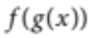 given that 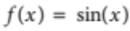 and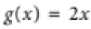?
A 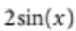
B 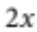
C 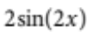
D 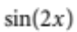
E 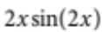
[1 mark]
2 A function can be identified as one-to-one if, for all values in the domain,
A 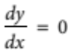.
B 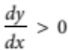.
C 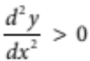.
D 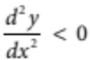.
E 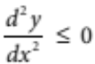.
[1 mark]
3 Write the inverse function of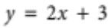.
A 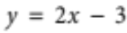
B 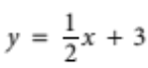
C 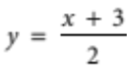
D 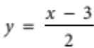
E 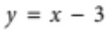
[1 mark]
4 Sketch the function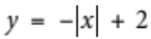.
A 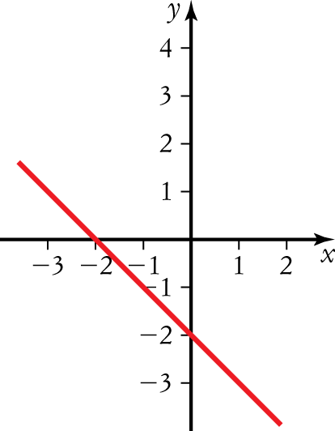 | D 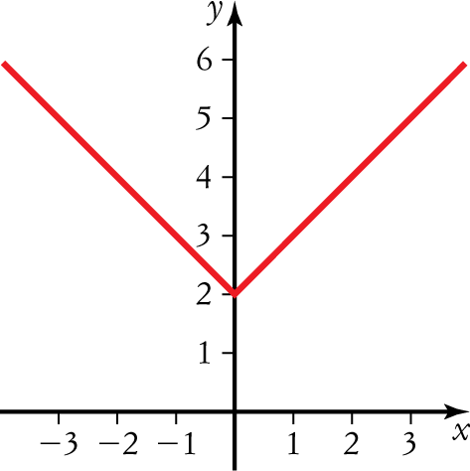
B 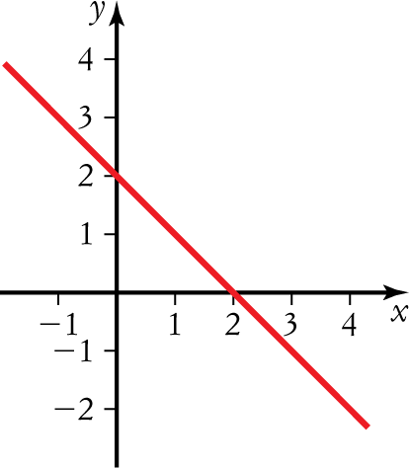 | E 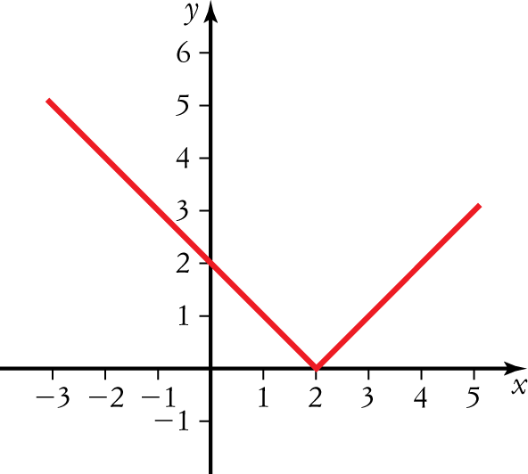
C 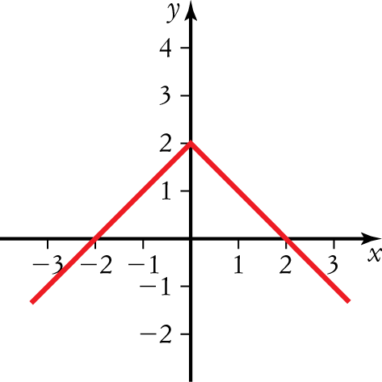

[1 mark]

5 Which graph represents the reciprocal function of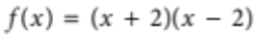?
A 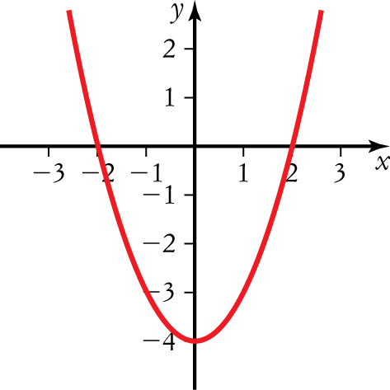 | D 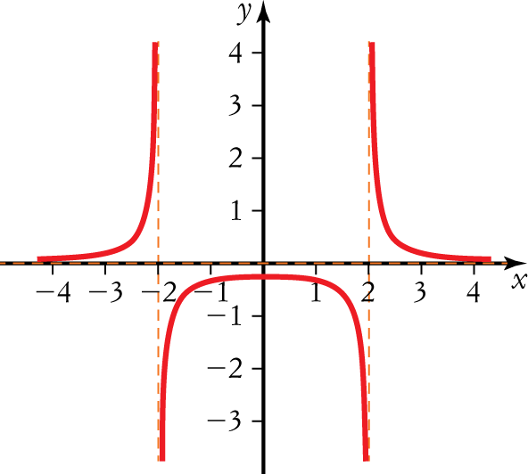
B 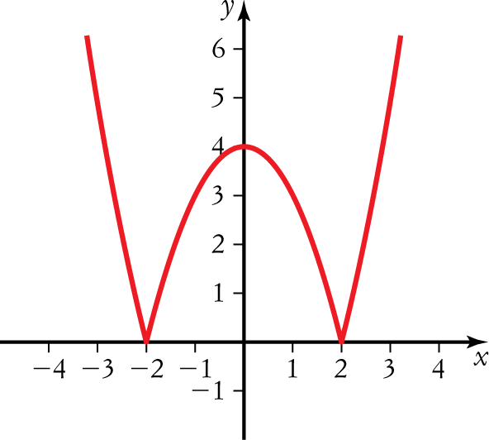 | E 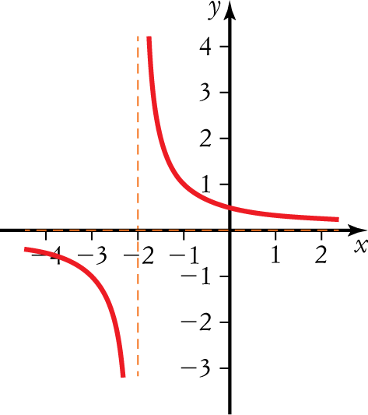
C 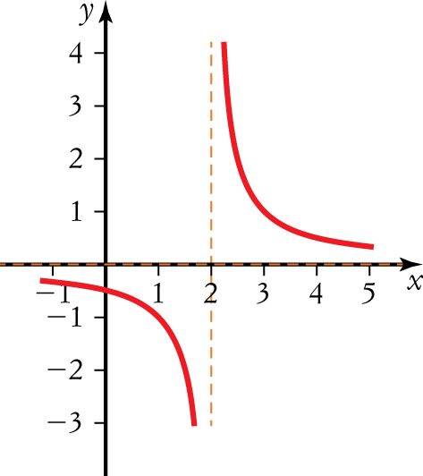
[1 mark]

Part B
Short-answer questions
8 short-answer questions
16 marks
Show your working where appropriate.
1 Sketch the graph of 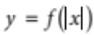 given that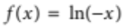.
[2 marks]
2 Sketch the graph of 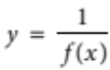 given that. Write the domain of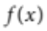.
[2 marks]
3 Sketch the graph of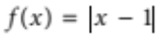. Write the range of.
[2 marks]
4 Sketch the graph of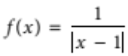. Write the domain of.
[2 marks]
5 Sketch the graph of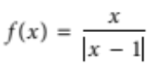. Write the range of.
[2 marks]
6 Sketch the graph of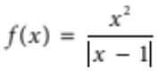. Write the domain of.
[2 marks]
7 Sketch the graph of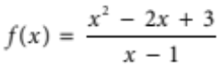.
[2 marks]
8 Write a rational function for the following graph.
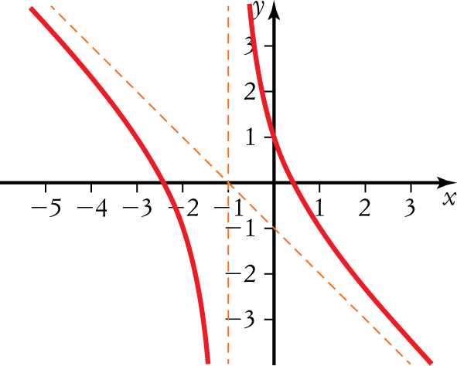
[2 marks]

Part C
Analysis questions
2 analysis questions
6 marks
Show your working where appropriate.
1 Solve the inequality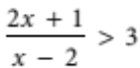, by sketching functions.
[3 marks]
2 A university environmental team are studying the cost to remove contaminated soil. The function 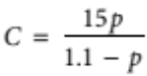 models the estimated cost (C in 1000s) to remove the percentage (p as a decimal) of the contaminated soil.
a State a reasonable domain and range for the function.
b Use a graph of the function to find the percentage of the contaminated soil that could be removed on a budget of $75 000.
[3 marks]
[Total marks: 27]

Answers
Part A – Multiple-choice questions [1 mark each]
1 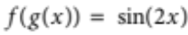,
D [1 mark]
2 Increasing ,
 B [1 mark]
3 ,
 D [1 mark]
4 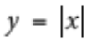 is inverted and moved up 2 to make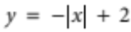.
 C [1 mark]
5 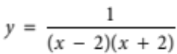,
 D [1 mark]
Part B – Short-answer questions
1 Graph:
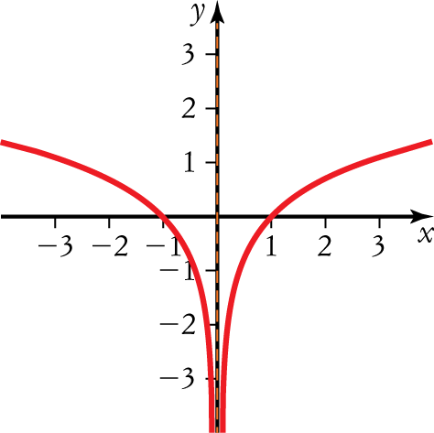
[2 marks]
2 Domain: 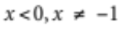 [1 mark]
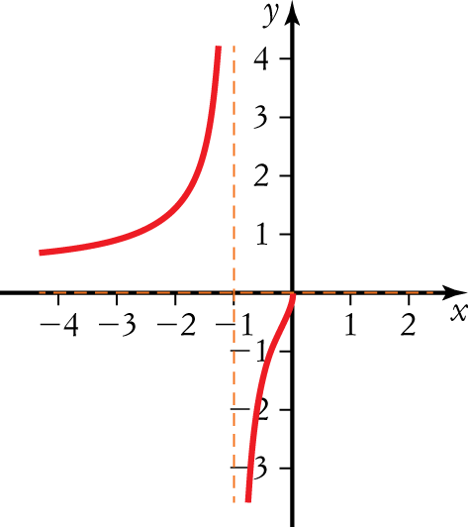 [1 mark]
[2 marks altogether]

3 Range: 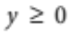 [1 mark]
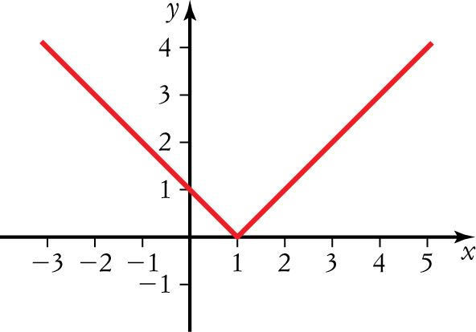 [1 mark]
[2 marks altogether]
4 Domain: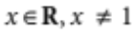 [1 mark]
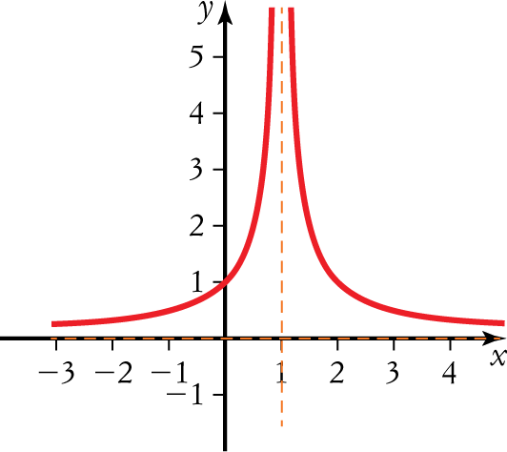 [1 mark]
[2 marks altogether]
5 Range: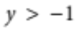 [1 mark]
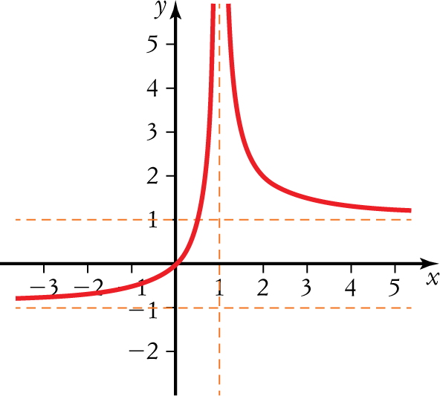 [1 mark]
[2 marks altogether]
6 Domain: 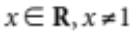 [1 mark]
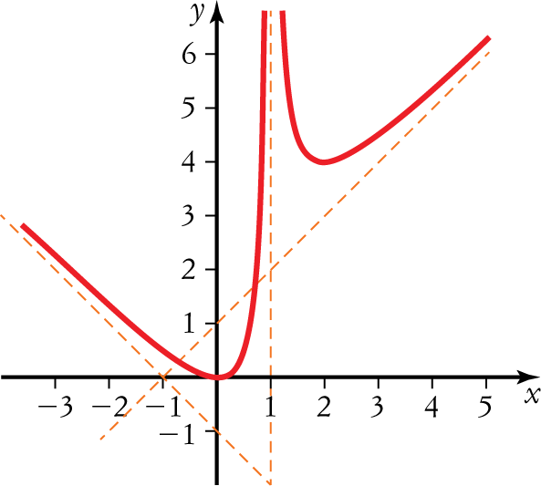
[1 mark]
[2 marks altogether]
7 Asymptotes [1 mark]
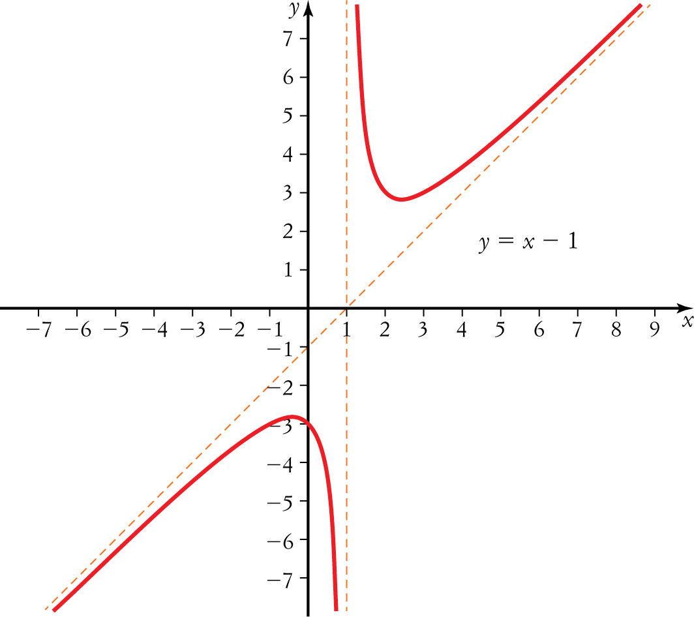
[1 mark]
[2 marks altogether]
8 Correct denominator [1 mark]
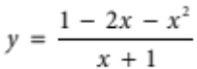 [1 mark]
[2 marks altogether]
Part C – Analysis questions
1 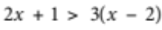, [1 mark]
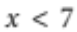
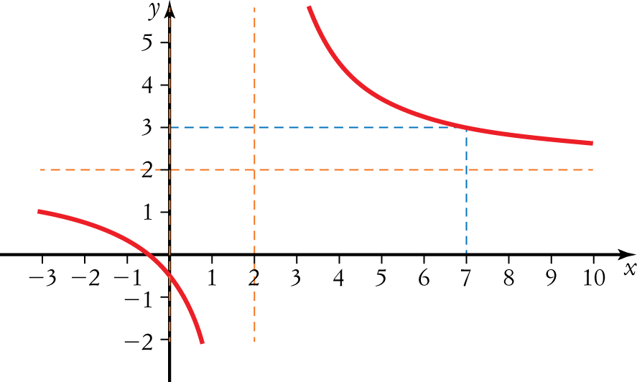
[1 mark]
Solution is 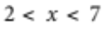 [1 mark]
[3 marks altogether]

2 a Domain: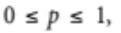
Range: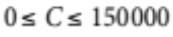 [1 mark]
b 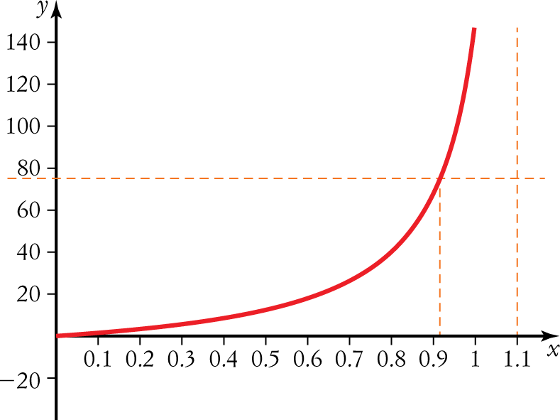
[1 mark]
0.92 or 92% of contaminated soil can be removed. [1 mark]
[3 marks altogether]

